PRACTICAL - 5
AIM: Write a Python code to identify SQL Injection vulnerabilities and mitigate them.
Solution:
Introduction
SQL Injection is one of the most common and severe vulnerabilities in web applications. It occurs when untrusted input is inserted directly into an SQL query, allowing attackers to manipulate the query and access unauthorized data. To address this issue, secure coding practices such as parameterized queries (prepared statements) are used.
Procedure
Step 1: Identify SQL Injection Vulnerability
The following Python code shows a vulnerable login system where user input is directly concatenated into the SQL query. This allows an attacker to manipulate the query using malicious input.
# vulnerable_login.py
import sqlite3

# Database Connection
conn = sqlite3.connect("users.db")
cursor = conn.cursor()

# Creates users table if not exists
cursor.execute("CREATE TABLE IF NOT EXISTS users (username TEXT, password TEXT)")
cursor.execute("DELETE FROM users") # reset table
cursor.execute("INSERT INTO users VALUES ('admin', 'admin123')")
cursor.execute("INSERT INTO users VALUES ('user', 'user123')")
conn.commit()

# User Input
username = input("Enter Username: ")
password = input("Enter Password: ")

# Vulnerable Query
query = "SELECT * FROM users WHERE username = '" + username + "' AND password = '" + password + "';"
print("Executing Query:", query)

cursor.execute(query)
result = cursor.fetchall()

if result:
print("Login Successful")
else:
print("Login Failed")

Example Attack:
Username1: admin’ --
Password1: anything
“ This logs in the attacker without checking the password, as the rest of the query is commented out. ”

Username2: ‘’ OR ‘1’=’1’
Password2: ‘’ OR ‘1’=’1’
“ This logs in the attacker because the condition '1'='1' always evaluates to true, bypassing authentication. ”

Step 2: Mitigation Using Prepared Statements
The vulnerability can be mitigated by using parameterized queries. In Python’s SQLite library, placeholders (?) are used for user inputs, preventing direct query concatenation.
# secure_login.py
import sqlite3
# Database Connection
conn = sqlite3.connect("users.db")
cursor = conn.cursor()
# User Input
username = input("Enter username: ")
password = input("Enter password: ")
# Secure Query using Parameterized Statements
query = "SELECT * FROM users WHERE username = ? AND password = ?"
print("Executing Secure Query with Parameters")
cursor.execute(query, (username, password))
result = cursor.fetchall()
if result:
print("Login Successful")
else:
print("Login Failed")
In this approach, malicious input is treated as plain data rather than executable SQL, thus preventing SQL injection.
Step 3: Results of the Execution
1. Vulnerable Code Execution
- Input: admin’ -- / anything
- Output: Login Successful (Password Bypassed)
- Database queried with unsafe SQL
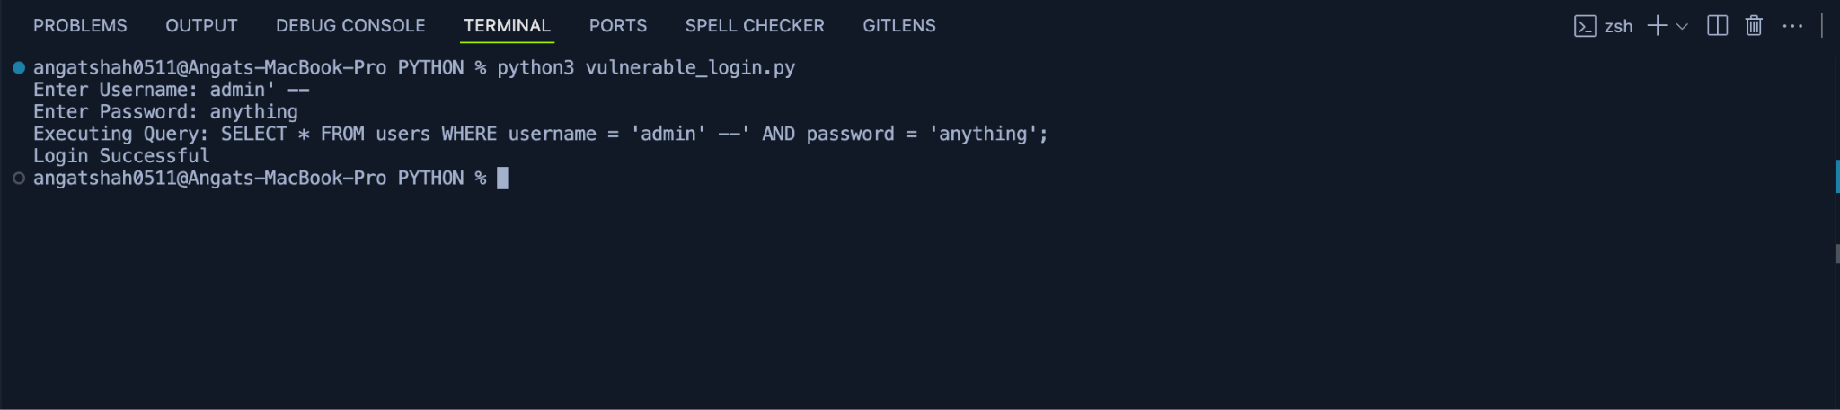

2. Secure Code Execution
- Input: admin’ -- / anything
- Output: Login Failed
- Parameterized query prevents manipulation
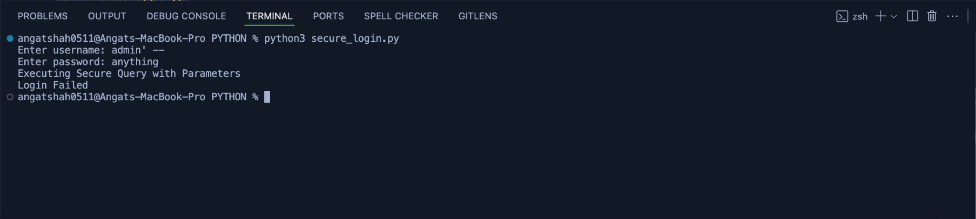

3. Database Table Content
- User1: admin / admin123
- User2: user / user123
The database remains unchanged during both executions, but in the vulnerable case, access control is bypassed.

